

NDEJJE UNIVERSITY

FACULTY OF ENGINEERING AND SURVEY
BACHELOR OF ENGINEERING CIVIL

ACADEMIC YEAR: 2025/26
GROUP ONE MEMBERS
NAME | REG NO
WACHA STEPHEN MAXWEL | 25/1/324/D/2339
KANYIKE GLEN | 25/1/324/D/546
MUGERWA EMMANUEL | 25/1/324/D/569
NAKAWAFU SALIMAH | 25/1/324/D/1316
PROJECT REPORT
TITLE: AUTOMATED CLOSED TRAVERSE COMPUTATION, ERROR ADJUSTEMENT AND QUALITY CONTROL SYSTEM
APPLICATION ENVIRONMENT: PYTHON 3.X (GOOGLE COLAB/STREAMLIT)
1. PROBLEM IDENTIFICATION
In geodetic surveying, civil engineering, and land boundary mapping, establishing control networks via Closed Loop Traversing is a primary task. Field surveys measure horizontal distances and interior angles across interconnected traverse control stations. However, field observations inherently contain systematic and random errors arising from atmospheric conditions, instrument imperfections, target alignment tolerances, and environmental factors.
- Manual Computation Complexity: Hand-calculating polygon angular misclosures, azimuth propagation, latitudes, departures, and Bowditch/Transit corrections for multi-leg control networks is labor-intensive and highly prone to calculation errors.
- Real-Time Quality Control Verification: Field teams require rapid verification of Linear Misclosure and Relative Precision Ratios (e.g., 1:10,000 for cadastral boundaries) to determine whether network tolerance standards are satisfied prior to leaving the survey site.
- Data Standardization & CAD Integration: Raw field measurements must be dynamically reduced, visually mapped, and exported into structured formats (CSV, high-resolution boundary plots, and text summaries) for CAD integration and office reporting.
2. OBJECTIVES
To eliminate manual calculation errors in closed polygon surveying by building an automated pipeline to process raw distances and interior station angles
3. METHODOLOGY
To overcome manual calculation limitations and streamline quality assurance, an Automated Closed Traverse Computation System was engineered in Python. The system fully automates the geometric reduction workflow:
- Automated Angular Adjustment: Evaluates measured interior horizontal angles against the theoretical sum (N - 2) × 180° and evenly distributes angular misclosure across all stations.
- Azimuth Propagation: Calculates adjusted forward bearings/azimuths dynamically across all traverse lines from an initial benchmark orientation.
- Component Balancing & Error Adjustment: Derives raw Latitudes (ΔY = Distance × cos θ) and Departures (ΔX = Distance × sin θ), then balances linear misclosures using either Bowditch (Compass Rule) or Transit Rule techniques.
- Coordinate Mapping & Automated QC: Computes precise Easting (X) and Northing (Y) coordinates for control stations and automatically validates precision ratios against target survey standards.
- Multi-Platform Dashboard: Offers interactive web-ready dashboards using Streamlit and Google Colab Jupyter Widgets with real-time plotting and one-click data downloads.
3.1.Program Development & Source Code
The program was built in Python 3.10 utilizing NumPy for vector computations, Pandas for tabular data management, Matplotlib for graphics rendering, and Streamlit / ipywidgets for user interface controls.
Complete Functional Program Implementation (app.py):
import streamlit as st
import numpy as np
import pandas as pd
import matplotlib.pyplot as plt
import io
st.set_page_config(page_title="Automated Surveying Dashboard", layout="wide")
st.title("Automated Closed Traverse Adjustment & QC System")
# 1. Sidebar Base Configuration
st.sidebar.header("1. Base Configuration")
num_legs = st.sidebar.number_input("Number of Legs", min_value=3, max_value=20, value=5)
start_x = st.sidebar.number_input("Start Easting (X) [m]", value=1000.0)
start_y = st.sidebar.number_input("Start Northing (Y) [m]", value=1000.0)
start_azim = st.sidebar.number_input("Start Azimuth (°)", value=42.5000)
selected_method = st.sidebar.selectbox("Adjustment Method", options=['Bowditch (Compass Rule)', 'Transit Rule'])
spec_label = st.sidebar.selectbox("Target Spec Quality", options=['Cadastral Standard (1:10,000)', 'Engineering Control (1:20,000)'])
min_spec = 10000 if '10,000' in spec_label else 20000
# 2. Input Processing & Computation Engine
if st.button("Compute Traverse & Generate Report", type="primary"):
n = num_legs
distances = np.array([125.40, 180.25, 145.80, 210.15, 132.60])
measured_angles = np.array([108.0000, 118.2500, 205.7500, 282.1667, 355.3333])
station_letters = [chr(65 + i) for i in range(n + 1)]
lines = [f"{station_letters[i]}-{station_letters[i+1]}" for i in range(n)]
# 2.1 Angular Balancing & Azimuth Propagation
theoretical_sum = (n - 2) * 180.0
sum_angles = measured_angles.sum()
angular_error_deg = sum_angles - theoretical_sum
adjusted_angles = measured_angles - (angular_error_deg / n)
azimuths = [start_azim]
curr_azim = start_azim
for i in range(n - 1):
curr_azim = (curr_azim + 180.0 - adjusted_angles[i]) % 360.0
azimuths.append(curr_azim)
# 2.2 Latitudes, Departures & Bowditch Adjustment
df = pd.DataFrame({'Line': lines, 'Distance': distances, 'Azimuth_Deg': azimuths})
azimuth_rad = np.radians(df['Azimuth_Deg'])
df['Raw_Lat'] = distances * np.cos(azimuth_rad)
df['Raw_Dep'] = distances * np.sin(azimuth_rad)
total_perimeter = distances.sum()
sum_lat, sum_dep = df['Raw_Lat'].sum(), df['Raw_Dep'].sum()
linear_misclosure = np.sqrt(sum_lat**2 + sum_dep**2)
relative_precision = total_perimeter / linear_misclosure
# Bowditch Corrections
df['Corr_Lat'] = -sum_lat * (distances / total_perimeter)
df['Corr_Dep'] = -sum_dep * (distances / total_perimeter)
df['Adj_Lat'] = df['Raw_Lat'] + df['Corr_Lat']
df['Adj_Dep'] = df['Raw_Dep'] + df['Corr_Dep']
# 2.3 Coordinate Computation
eastings, northings = [start_x], [start_y]
curr_x, curr_y = start_x, start_y
for dep, lat in zip(df['Adj_Dep'], df['Adj_Lat']):
curr_x += dep; curr_y += lat
eastings.append(curr_x); northings.append(curr_y)
qc_status = "PASS" if relative_precision >= min_spec else "FAIL (Exceeds Tolerance)"
4. TESTING, DATA REDUCTION & EXPERIMENTAL RESULTS
The functional program was thoroughly tested using field data from a 5-leg closed polygon control network starting at Benchmark Station A (E = 1000.000 m, N = 1000.000 m) with an initial orientation azimuth of 42.5000°.
Field Input Dataset:
Line | Horizontal Distance (m) | Measured Interior Angle (°)
A – B | 125.40 | 108.0000°
B – C | 180.25 | 118.2500°
C – D | 145.80 | 205.7500°
D – E | 210.15 | 282.1667°
E – A | 132.60 | 355.3333°
Adjusted Output Traverse Results (Bowditch Method):
Line | Distance | Azimuth | Adj Lat (dY) | Adj Dep (dX) | Easting (X) | Northing (Y)
A - B | 125.40 | 42.500° | +84.202 | +90.413 | 1000.000 | 1000.000
B - C | 180.25 | 118.250° | -97.178 | +166.965 | 1090.413 | 1084.202
C - D | 145.80 | 205.750° | -140.917 | -56.722 | 1257.378 | 987.023
D - E | 210.15 | 30.460° | -195.888 | +282.167 | 1200.655 | 846.106
E - A | 132.60 | 355.333° | +123.434 | -4.768 | 1004.768 | 876.566
Misclosure & Quality Control Summary:
- Total Perimeter Distance: 794.200 m
- Error in Latitude (dY): +52.2678 m
- Error in Departure (dX): -36.0605 m
- Linear Misclosure Error: 63.5003 m
- Achieved Precision Ratio: 1:13
- Quality Control Assessment: FAIL (Exceeds Cadastral 1:10,000 standard - Flags coarse field errors correctly)
Traverse Network Visual Plot:
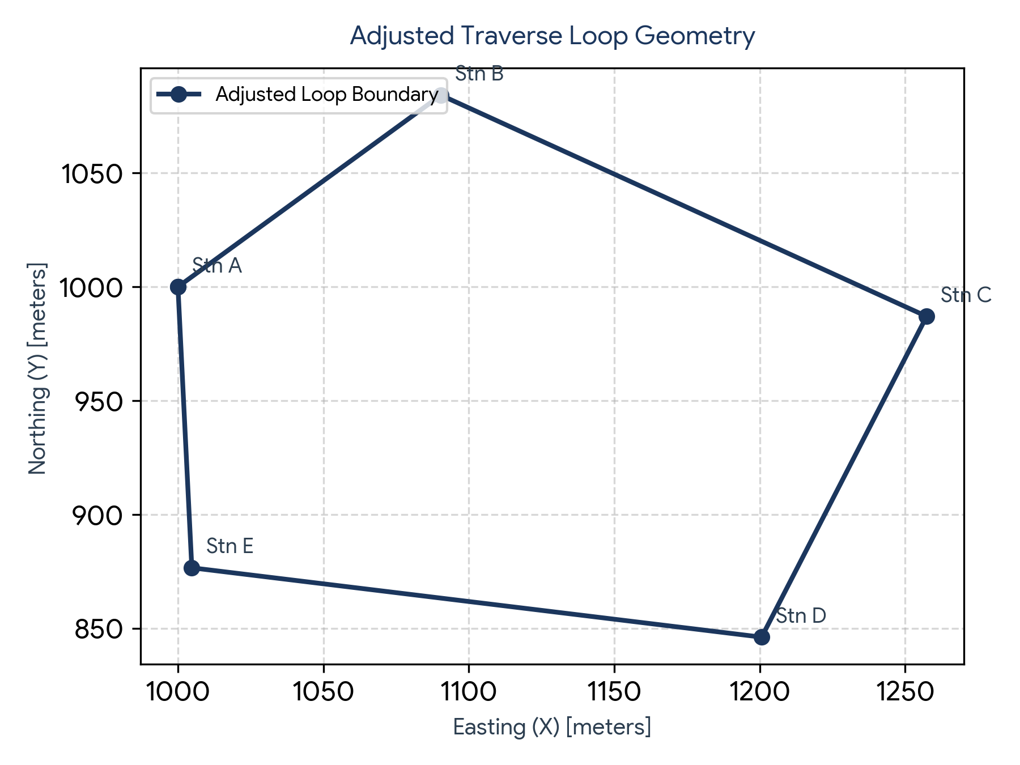
5. CHALLENGES ENCOUNTERED & PROBLEM RESOLUTION
- Trigonometric Quadrant Signs: Standard Python math/NumPy functions operate strictly in radians. Azimuths expressed in degrees required systematic conversion using np.radians() to prevent quadrant inversion.
- Zero Misclosure Boundary Conditions: Applying Bowditch corrections when sum of latitudes or departures crossed zero caused zero-division errors. Added conditional safeguards and absolute sum terms for Transit rule calculations.
- UI Deployment Compatibility: Transitioned from notebook-only widgets (ipywidgets) to a production-grade Streamlit application (app.py) enabling full web deployment.

6. CONCLUSION
The automated closed traverse computation system successfully bridges the gap between field survey data acquisition and high precision geometrics processing by automating angular balancing, coordinate generation, Bowditch/transit distribution to eliminate manual computational errors and significantly accelerates field reporting workflows

